**Chapter 65 – Year 2014**

**Vacation to Shellie & Roy’s in May**

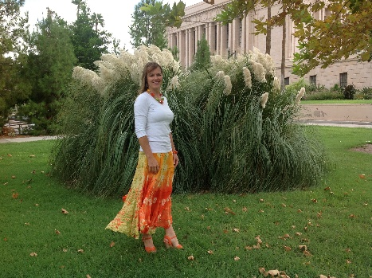I haven’t been home much in the last 4 weeks as I went to Shellie & Roy’s home for Garrett’s graduation from ASU and Kevis’s high school graduation. I had a wonderful two weeks with them. We did lots of fun things. They have a beautiful boat so we went to the lake one day and Garrett, Nora & Little Maggie went with us. Both Garrett and his mom are fantastic on the water. Roy is recuperating from his hip replacement operation so he didn’t do much, but he did get out on the wakeboard one time. Jase, Nora & I got on the knee board (at different times). My broken elbow was still healing so I didn’t dare do much either, so they just pulled me around as I laid on the knee board. Nora got up on her knees. She was really nervous at first to even get out on it, but she had fun. Shellie & I played lots of games at their home. Nora played with us when she was with us. Neither Roy, nor any of their sons like to play board and card games. We watched several movies in their theater room and Shellie and I did lots of visiting as we went shopping, doing laundry or just sitting and talking. We went to the Mesa Temple and took pictures on the grounds, after the session. Shellie is a beautiful and special daughter.

Ken really missed me, I missed him too and wish he could have gone, but they needed him to take his school bus route, especially at the end of the year as they have lots of field trips and sports events. Ken picked me up at the airport at 6 pm on Memorial Day and we were happy to be together again. We went out to dinner and enjoyed the evening together.

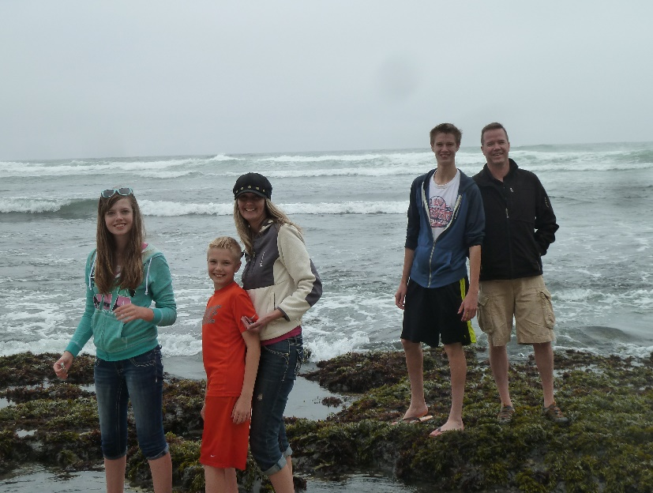**VACATION WITH DAVID, SHAUNA & FAMILY TO CALIFORNIA IN JUNE 2014**I was busy doing laundry and repacking to leave on vacation on Friday morning with David, Shauna and their family. Her parents went also. Shauna is great in planning vacations and making all the arrangements, so we had a great time. We stayed in a home on the beach at Half Moon Bay. It was beautiful and so was the ocean. It was a little chilly as it didn’t get over 62 degrees, but it was so pretty. We were down at the ocean several 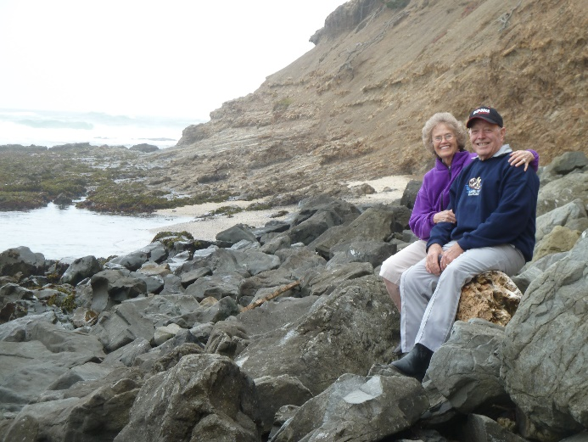times, then going on the paths in the park across from this home where the path overlooked the ocean and we saw lots of seals resting on the rocks or on the beach (depending on when the tide was in or out.). In the mornings they have “tide pools” where you can see all kinds of animal life. We saw star fish, squid, snails, crabs, sea urchins, etc. We drove down to the pier one afternoon and went fishing for large crab. That was a fun experience too. We stayed two nights there and then drove to Yosemite where Shana had rented a cute ranch house for us on this large ranch about 40 minutes from Yosemite National Park. We had all the comforts of home there too, plus it has beautiful surroundings. Tyler, Conner, David and Ken played horse shoes and several of us got in the hot tub. We also hiked a mile to their fun pond where they had paddle boats and a canoe. That was lots of fun. The next day we went to Yosemite and spent the day. It was so beautiful and the weather was just perfect. We all enjoyed it so much. The only thing that was hard was finding parking spots for all three cars as we drove from place to place. There were so many tourists there. The following morning, we drove 11 hours to St. George. The children took turns riding with their parents and both sets of grandparents. Shauna’s parents 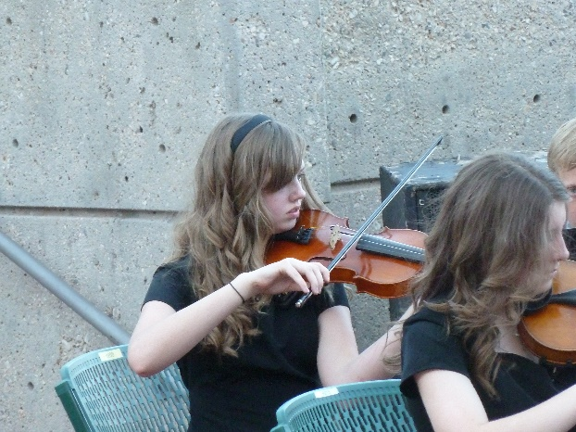have bought a condo in St. George so we all stayed there for two nights. We swam in the pool, played games, visited and Shauna, Vickie (Shauna’s Mom) and I went shopping**. Emily plays the violin very well now and is in a small strings orchestra and they performed prior to the play “The Wizard of Oz” at tuacon**. We also had tickets for dinner there and it was very good. I was afraid it would be really hot as it had been 108, but the sun had gone behind those beautiful red mountains so it wasn’t so bad, in fact it was quite nice.

Ken and I drove home the next day and stopped at Mike and Becky’s to visit them. They had us stay for dinner and while it was cooking we played Rook. David, Shauna and family stayed at St. George an extra day, but I needed to get home to teach my primary class as the other teacher had taught 3 weeks in a row for me. We experienced cool weather at the ocean, beautiful warm weather in the mountains at the ranch house and Yosemite, and then hot weather in St. George. Quite a vacation. We are still tired from all the traveling (we traveled about 2,500 miles on this trip, but it was sure fun.

**SANDI & JANAE**

We needed to work in our garden and yard this morning and I’ve been doing lots of laundry, so we will rest a little more tomorrow. We leave on the 20th to go out to Sandi’s to spend the night as we will be leaving early the next morning to go to Lake Tahoe. I think I have said that Sandi had a couple of time shares there this year and has invited Shellie and all her family and Ken and I to go with them. Chelci, Steve and their family are going too. Sandi & JaNae are having problems again and not speaking much with each other, so they are not going. Sandi wanted to take JaNae’s children, but JaNae won’t let her. I feel bad for both of them and the children and hope they can forgive each other and have love for each other again. JaNae is a sweet girl, but too much like her dad, I’m afraid. Ken and I were able to go watch Kennedy, JaNae’s daughter clog in competition at Lagoon about five weeks ago. JaNae acted excited that we were there, and so did Kennedy. JaNae teaches clogging, like her mom used to do, and she is really good at it. I had called to see how Brad, her husband was doing as he had neck surgery, and she told me about this competition. They are really struggling – financially, emotionally and Brad is suffering with health problems. I worry about them and their three children.

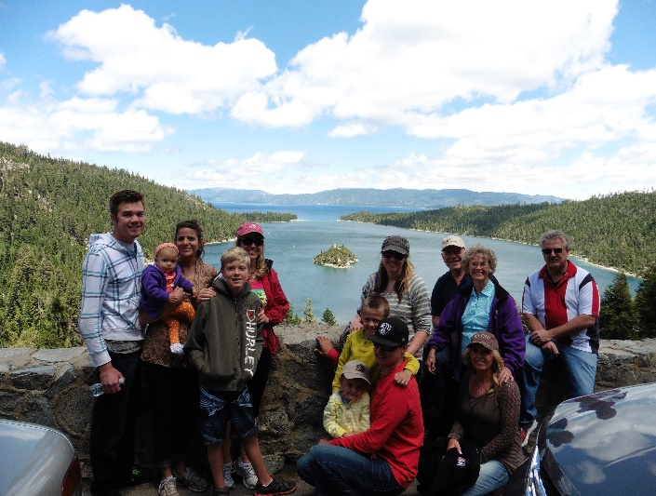**LAKE TAHOE WITH SANDI, NICK, CHELI, STEVE & CHILDREN, SHELLIE, ROY, GARRETT, NORA & MAGGIE AND KEN & I**

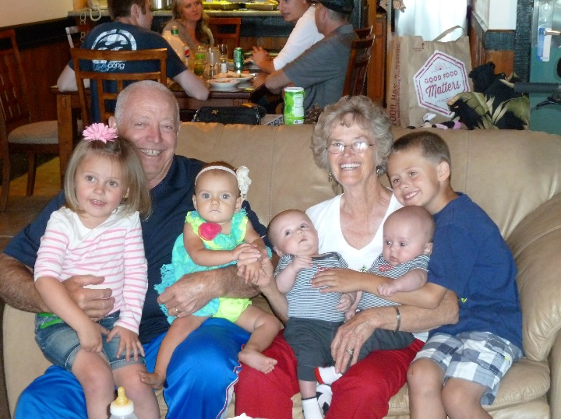Sandi had two-time shares at Lake Tahoe, so she invited Chelci, Steve & their children, Ken & I, Shellie, Roy, Jase and Garrett, Nora & little Maggie came with them. Sandi & Nick and Chelci, Steve & children stayed in the one in downtown Lake Tahoe and Shellie, Roy, Jase, Garrett, Nora & Maggie and Ken & I stayed in the one up in the mountains. Both places were great and so different. We took turns fixing the meals and when we were with Sandi’s group, we had delicious meals that Sandi & Chelci prepared and afterwards we would go swimming in the pool or play ping pong and other games. Ken & Nick played Chess with big chess pieces by the pool. We also went shopping and to the art festival downtown. When Shellie, Nora and I fixed meals, the others came up to our place. There wasn’t as much to do where we were, but the view and scenery were spectacular. The accommodations were great at both places.

We went on outings to the beach at the lake one day, another day we went sightseeing and hiked some. We saw beautiful waterfalls; we walked down to a mansion and went through it. We did lots of fun things and had a great time. However, Nick & Sandi were having problems and while walking with Sandi, she told me that she hoped I wouldn’t hate her, but that she was going to divorce Nick as she couldn’t take it any longer. She said he didn’t want to do anything fun, all he wanted to do was watch sports. He didn’t help her with the yard or housework, he didn’t show her affection and she said she had about 20 more good years and she wanted to have fun and do things. I told her that I certainly wouldn’t hate her, that she was my daughter and I loved her very much and I wanted her to be happy.

**KENNETH H BROWNING FAMILY REUNION – Held July 10 to 14, 2014**

**Held at our home in Clinton – great fun with family (Put in pictures)**

**Thursday, July 10, 2014**

After breakfast I went over and got Kylan and then up to David’s and got Conner. The two of then helped us get the yard cleaned up and mowed the lawns. Time went very fast today. Scott and Jeff came over after work and help us get things ready for tomorrow. Storm threatened so we did not put the canopy all the way up, but will finish it tomorrow. Shellie and Jase arrived here this evening. We were up late visiting.

**Friday, July 11, 2014**

We got things about ready. We started to prepare the Dutch ovens but needed Sandi’s. She let us know she was on the way. A short while later she called to tell me that she had just blown a tire on the trailer. She was on the Legacy Highway by Bountiful. A young man stopped and helped her. I had Shellie and Mae drive to help her but the young man drove her to Bountiful where she bought new tires for the trailer. Mae and Shellie got the stove and Dutch and brought it back to me. I had all the chicken browned with part of it in the kitchen oven as I only the two ovens Dutch ovens. They got back just as I was starting to load the vegetables in with the chicken. I was sure busy without having Mae or anyone else to help me. As it was they got back just in time and I was able to get the three ovens going. It turned out to be a very good meal. Mike and Becky didn’t come but Becky brought Maddi and Jessie and met Jeff in Salt Lake and he brought them on. Mike is still sick but hopes to join us tomorrow. It was interesting getting everyone’s campers set up, as well as cleaning up the Dutch ovens and help set up a screen and outdoor projector so that we could watch a movie tonight. I think everything worked out ok but it was after mid-night before we got to bed very tired.

**Saturday, July 12, 2014**

David and Shauna prepared breakfast of hot cakes and eggs, they were very good. The children sure enjoyed the swimming pool. Every one enjoyed visiting, playing games of all kinds from table games to volleyball. Gail and Shellie bought sandwiches from Wall Mart. Mae had thought that everyone would enjoy going water skiing at one of the lakes or going to a water park but they all wanted to continue visit and playing games. The little ones played constantly in the pool plus we had water balloons and water guns so they were having fun all day. Scott and Mishelle provided the evening meal of spaghetti with homemade rolls. Having the portable toilet was a help plus we went through lots of water and cups but it was a great day. David and Sierra came for a while this afternoon and both seemed to enjoy the activities. Some of the children wanted to have another movie but I think everyone was too tired of having fun to stay up late for a movie.

**Sunday, July 13, 2014**

Sandi and Shellie made muffins, scrambled eggs, special fruit drinks for breakfast. Shellie and Jase went to Sacrament meeting with us and Gail took the children to their Ward so that Ben could sit on the stand with the Bishop. I feel bad that none of the rest of our family are not more active. We only attended Sacrament meeting but it was sure special. There were a lot of visitors today as the Searl boy is leaving on a mission on Tuesday and Jake Steadman just returned last Tuesday. Both of them gave very good talks. Mike and Becky haven’t been here as Mike has been sick. We are glad that Mattie and Jessie have been able to be with us. We played a lot of table games again this afternoon. Scott and Michelle prepared South West Chicken for lunch and that was sure good. This evening we just had left over’s and hot dogs for some of the children. Mike and Becky did come this afternoon although Mike is some better he still isn’t up to par. It has again been a very enjoyable today. We have had all our children, and many of our grandchildren, plus with Chelci coming Friday afternoon with her children, that made 4 Great Grandchildren that attended. Jeff and Gail took their family home tonight, plus Scott went home as he goes to work quite early. Mike took his Family home this evening.

**Monday, July 14, 2014**

Bob prepared biscuits and gravy for us and I fried up quite a few fish, so we had a big breakfast this morning. Everyone helped clean up and then everyone soon went home. Shellie and Jase went to Shellie’s friend, Brook, who lives in Sandy Utah. They will stay there for a couple of days and then head for home. Mae and I laid down and took a nap, although Bob knocked soon after we laid down and woke Mae so she didn’t get much sleep. We finished getting everything put away. Scott and Mishelle came back this evening to get some of their things out of the trailer. We were sure tired when we went to bed, but we did watch the series of WAR. I wasn’t very impressed with the show. It was mid-night when we went to sleep.

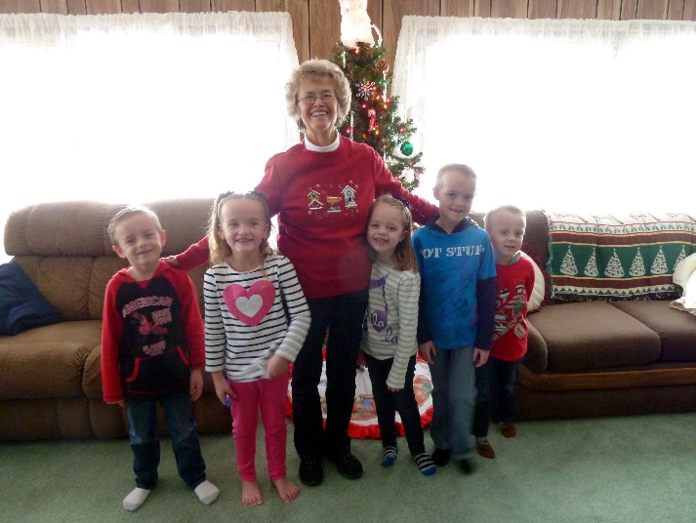**GRANDCHILDREN’S CHRISTMAS PARTIES**

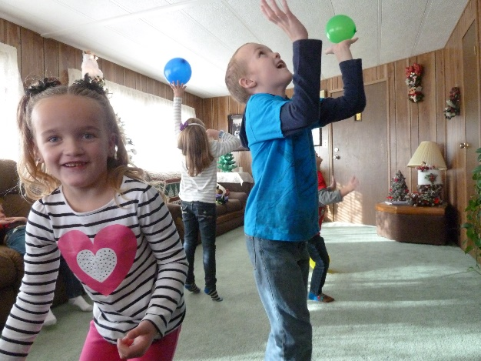I got this idea from Sister Marjory Hinckley’s book of her life. She had Grandchildren’s Christmas parties and I liked that idea. I knew the cousins would have fun together and it would make memories for all of us. The first time I had them, we lived in Clinton. It was 2007 and I invited all our grandchildren (except Shellie’s children who live in Arizona), and also some great grandchildren. JaNae children and even Brad’s son, Jaden, came. It was fun and some of the moms stayed to help me. We played games, had a fish pond and treasure hunt and we had pizza, pop, cupcakes (that we decorated) and ice cream. (I still do this with the younger Grandchildren.) I have had them every year since, except for the year 2010 when we were on our mission to California. Mike told me that Maddi had said to him “Isn’t Grandma going to have our Grandchildren’s Christmas party this year?” Mike told her that we were on our mission to California and so we were not here to be able to have it. She was disappointed as were the other grandchildren. The first few years I had all the grandchildren together. I didn’t have the great 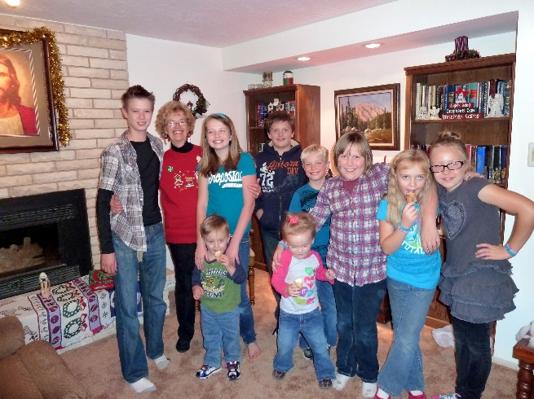grandchildren anymore as that was too much and Sandi said she would have one for her grandchildren. The last few years, I decided that there was such an age difference between the older grandchildren and the younger ones, that I would split them. At first, I held them on the same day, the younger ones from 10 am to 12:30 pm and the older ones from 12:30 pm to 4 pm. The last three or four years I have had the younger ones on a different day than the older ones. I did different things with the older ones. One year, I had us go to an Assisted Living Center in Clinton where Kylan played the piano for the people there, and Emily played her violin. Afterwards, we sang Christmas carols to them. That was a neat experience. We came back to our home, ate dinner and played games. In 2015, we ate dinner and afterwards we went caroling to our 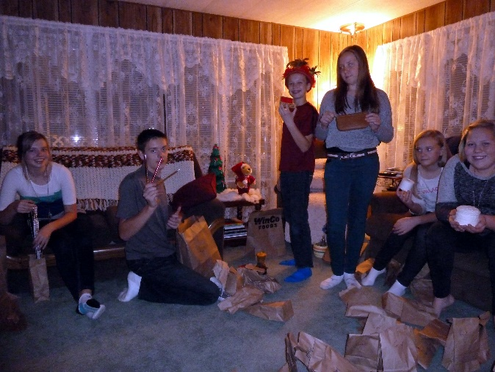neighbors. I had made goodies to take around to the neighbors, so we all went to these elderly neighbors where we sang Christmas carols to them and gave them our treats. Even though Tyler is 17 and they are all in their teens, they were all good sports and sang and were cute with our little widow neighbors. We came back and played games. Most years we just ate and then played all kinds of games – minit to winit games, white elephant gift game, Pictionary, Catch Phase, etc. One year I gave them gift wrap, ribbon, tape, scissors, bows, etc and had the boys compete again the girls decorating one of each of them. They had a good time.